**5.4.1 Details of Alumni Association Activities**

|  |  |  |  |  |
| --- | --- | --- | --- | --- |
| **S.NO** | **YEAR** | **DATE** | **PROGRAM** | **SPEAKER** |
| 1 | 2021-2022 | 29.09.2021 | Head & Neck Cancer- An Oral Surgeon’s Perspective | Dr. Keerthana Sri |
| 2 | 2021-2022 | 18.11.2021 | Its more than just a teeth- A Communication Webinar | Dr. Divya Bharathi |
| 3 | 2021-2022 | 23.03.2022 | Alumni Orientation Program | Dr. Priyadharshini |
| 4 | 2021-2022 | 23.03.2022 | Alumni Orientation Program | Dr. Bhuvaneswari MV |
| 5 | 2021- 2022 | 23.03.2022 | Alumni Orientation Program | Dr. Shruthi Kasthuri |
| 6 | 2021- 2022 | 23.03.2022 | Alumni Orientation Program | Dr. Keerthana Sri |
| 7 | 2021-2022 | 30.07.2022 | Orofacial clefts | Dr. Sembiyan |

**REPORT OF THE PROGRAM**

Date: 25/09/2021

Time: 9.30- 1.00 pm

TITLE : Head and Neck cancer- An Oral Pathologist’s & Oral surgeon’s

Perspective

CATEGORY : Continuing Dental Educational Webinar- National Level

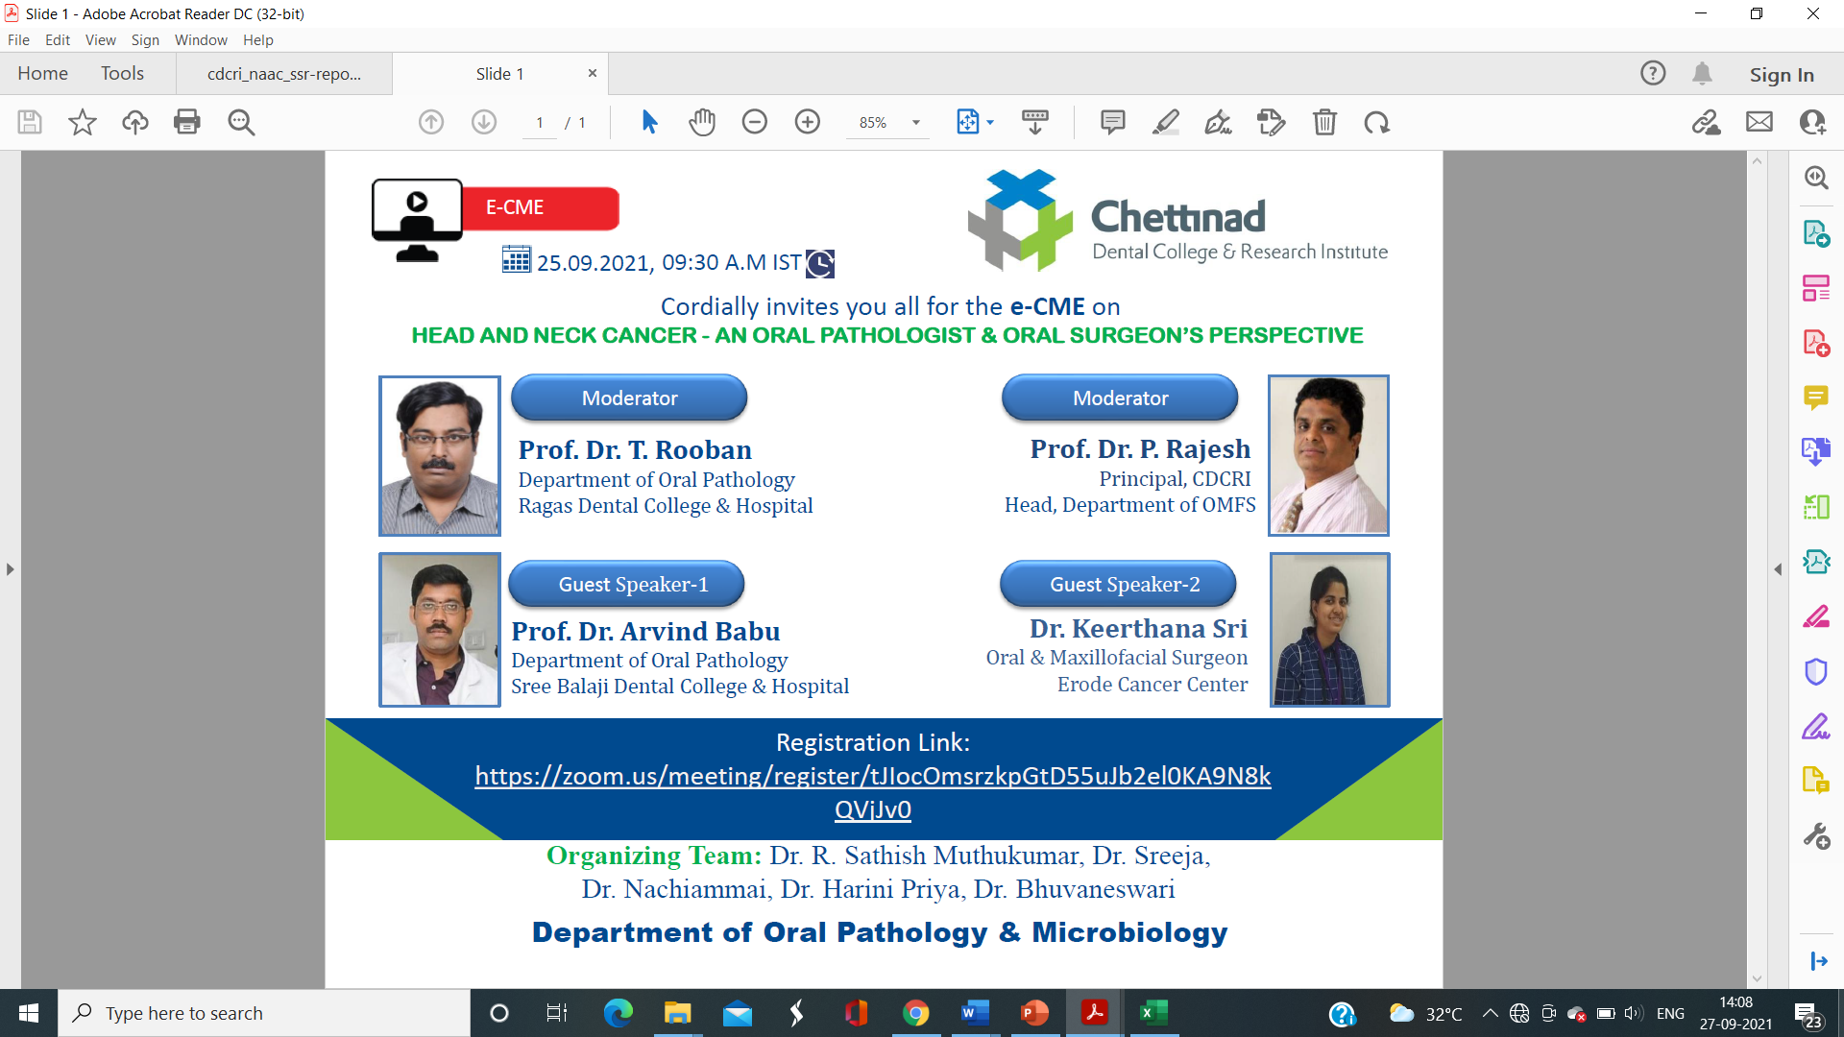

**PROGRAM HIGHLIGHTS:**

The program started virtually through Zoom application at 9.30 am. There was an overwhelming response with 474 registered participants. Various National and regional experts joined in the session along with undergraduate and post graduate students from various dental institutions. Dr. Sathish Muthukumar gave the welcome address followed by Dr. Sreeja’s introduction of the moderators.

The second part of the session began with an introduction by Dr. Bhuvaneswari of the speaker. Dr. Keerthana Sri (Guest Speaker-2) delivered her lecture on “Head and Neck Cancer - An Oral Surgeon’s perspective. The presentation was interesting with many clinical case scenarios. The session not only described about oral squamous cell carcinoma but also discussed about the other tumors as well as the various treatment plans like surgical, chemo- and radio- therapy on various cancers affecting head and neck region. The importance of nodal examination and as well as staging of the tumor was emphasized. The importance of surgical excision along with margins of the excised specimen was the key note of her presentation. It was followed by moderators views. Dr. Mahendra Perumal, Oral Surgeon from Erodeshared his expertise on post- surgical rehabilitation with few case scenario. The session concluded at 1.00pm with an end note and vote of thanks by Dr. R. Sathish Muthukumar and Dr. Harini Priya respectively. The feedback was received from 213 participants and analysis of it was attached.

**PROGRAM CONSTRAINTS:**

There was slight unstable network connection from the speaker’s end. Their audio as well as visual aids were interrupted during the session and measures shall be taken of those problems during future programs.

**ACKNOWLEDGEMENT:**

* The Department of Oral and maxillofacial pathology extends their thanks to The Dental council of India- Tamil Nadu Branch, for approving and crediting three points for the continuing dental education program
* Sincere Thanks to Mr. Manikandan & Mr. Jothi prakash- Information &communication Technology department of the institution for their technical support
* Thanks to the administration &amp; management of the institution for their support rendered.

FEEDBACK ANALYSIS- CDE PROGRAM

HEAD AND NECK CANCER FROM AN ORAL PATHOLOGIST & ORAL SURGEON’S PERSPECTIVE

Date: 25/09/2021

Venue: Virtual (Zoom)

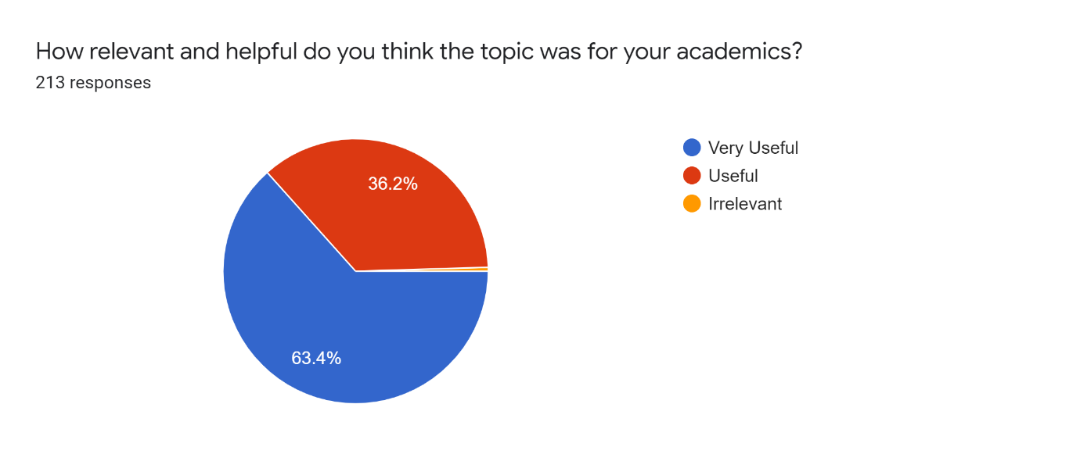

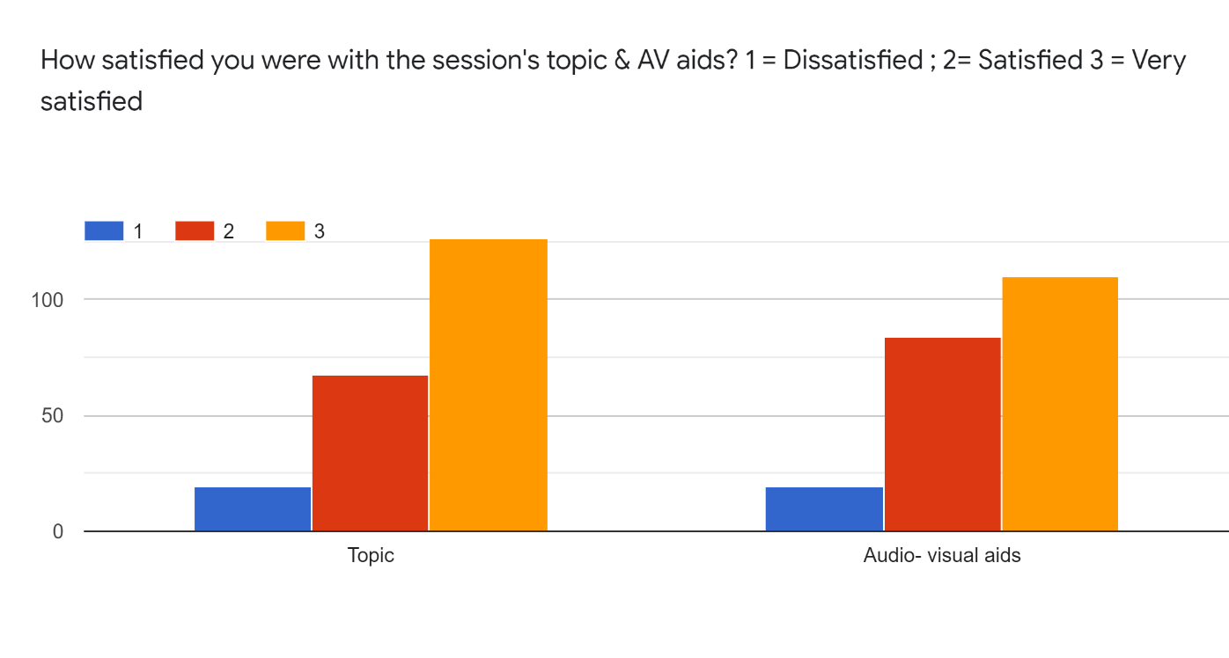

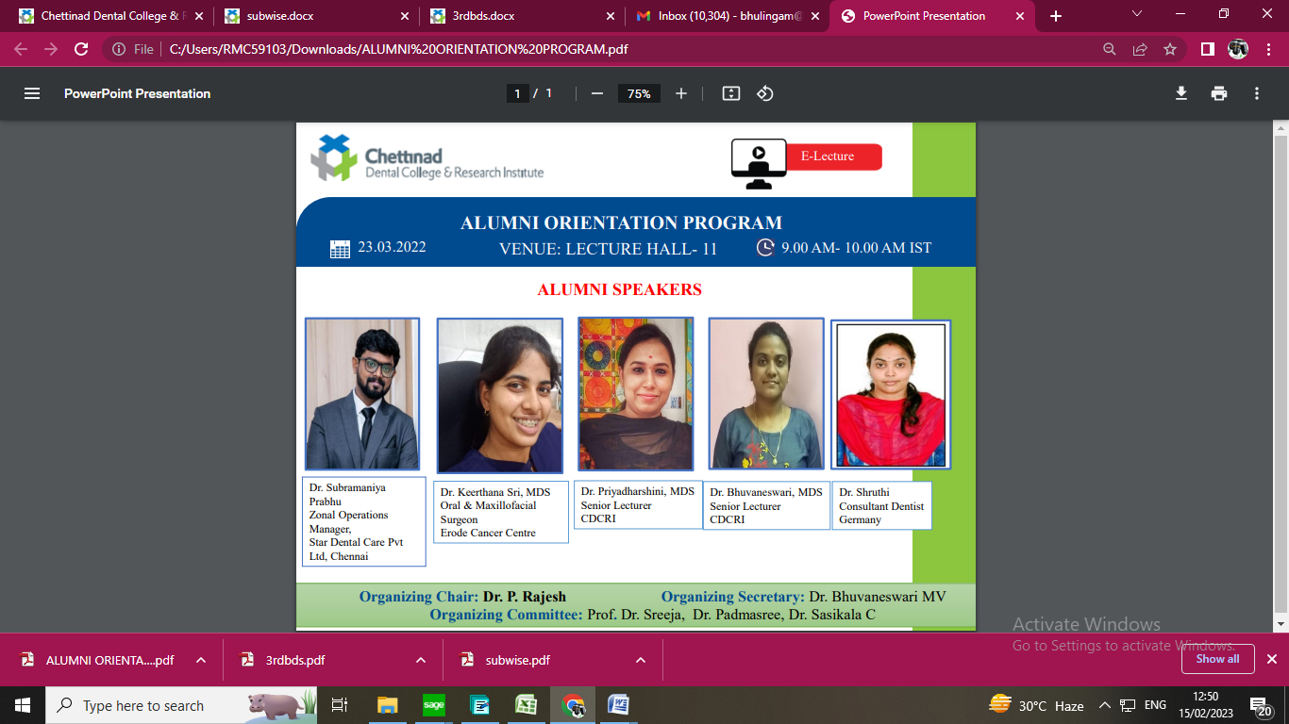

Date: 23/03/2022

Time: 9.00 am- 10.00 am

TITLE : Alumni Orientation Program

CATEGORY : Orientation Program- Regional Level

**PROGRAM HIGHLIGHTS:**

The program started with one hundred first year B.D.S students i.e freshers who joined the course for the academic year 2021- 2022. Dr. Sreeja gave introduction about alumni association and also introduction about alumni speakers. Dr. Priyadharshini, Treasurer, CLAW started her narration with how interesting and exciting was her days in the Chettinad dental college during her undergraduate times. She also discussed about the alumni association and its members, many of whom now have been settled in various countries. She motivated them by describing the career opportunities after BDS in india and abroad through her power point presentation.

Dr. Bhuvnaeswari, shared her memories with the students how Chettinad college and faculties care and teaching during their undergraduate time. She motivated them how to excel by breaking their inferiority complex and develop skills and knowledge here. She also discussed how the college trains them during this period of undergraduate time and how it will help in their career.

Dr. Shruthi Kasthuri, Who is currently working as consultant dentist in Germany shared her memories in Chettinad dental college and also gave a gratitude speech how Chettinad helped her to grow and attain current position in her career. She also discussed what are the career opportunities available in the foreign countries mainly in Europe after BDS.

Dr. Keerthana Sri, currently working as oral and maxillofacial surgeon in Erode Cancer Centre shared her memories as student in Chettinad dental college and also motivated them how the college and faculties helped them to attain the current position in her career. She also motivated them how as a student should learn the subject and utilize the facilities available in the college. The session ended by 10.30 am with vote of thanks by Dr. Priyadharshini.

**PROGRAM CONSTRAINTS:**

None

**ACKNOWLEDGEMENT:**

* Sincere Thanks to Mr. Manikandan & Mr. Jothi prakash- Information &communicationTechnology department of the institution for their technical support
* Thanks to the administration & management of the institution for their support rendered.

**FEEDBACK ANALYSIS:**

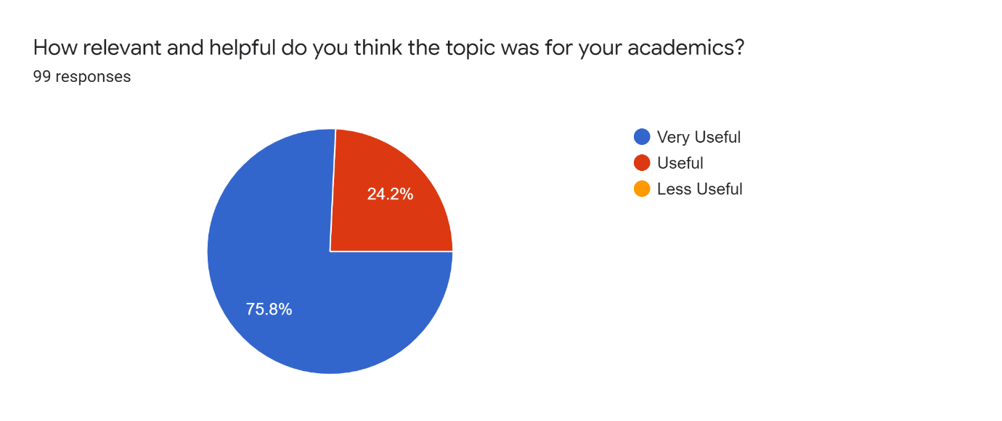

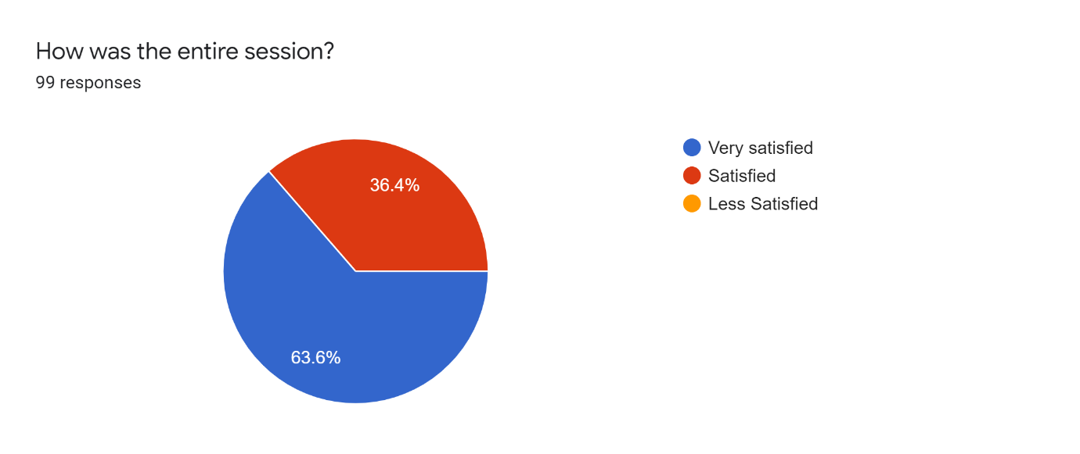



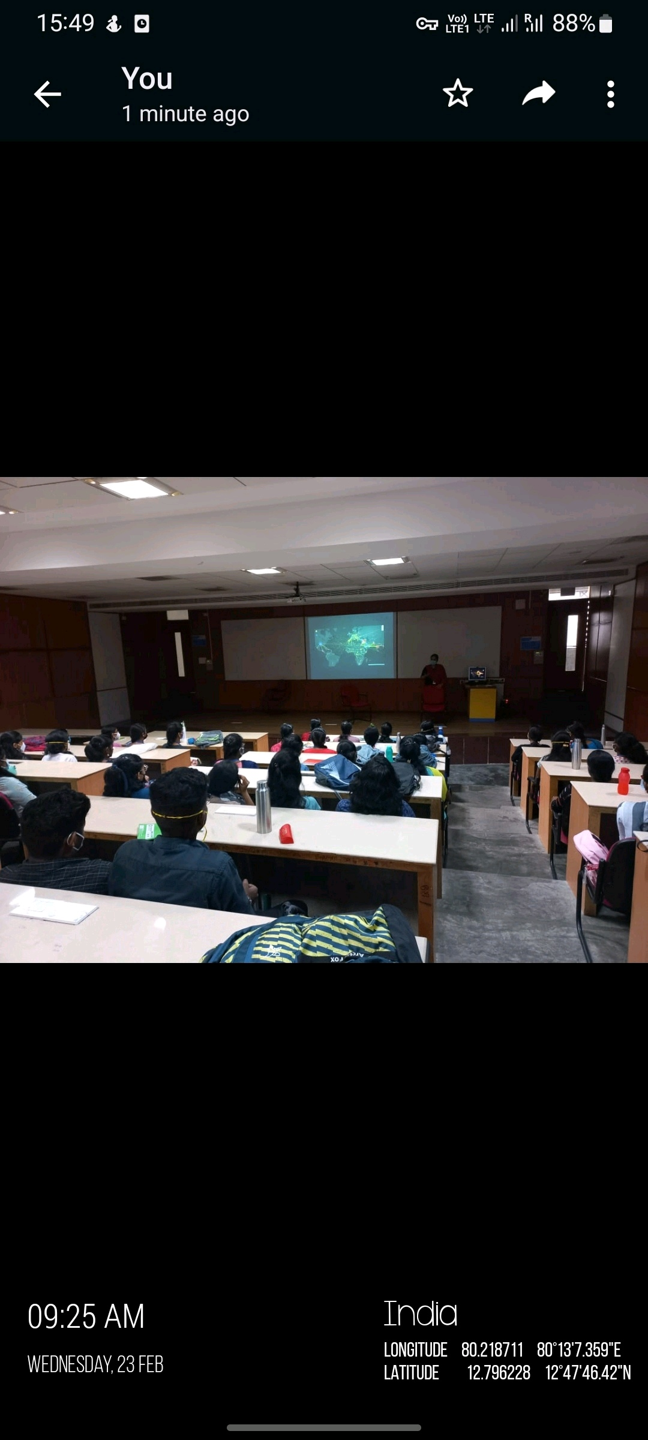

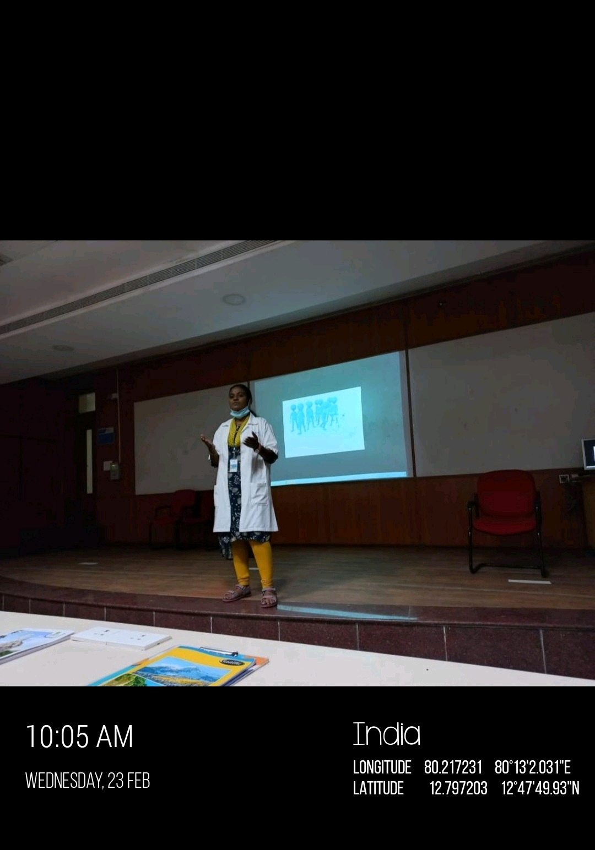

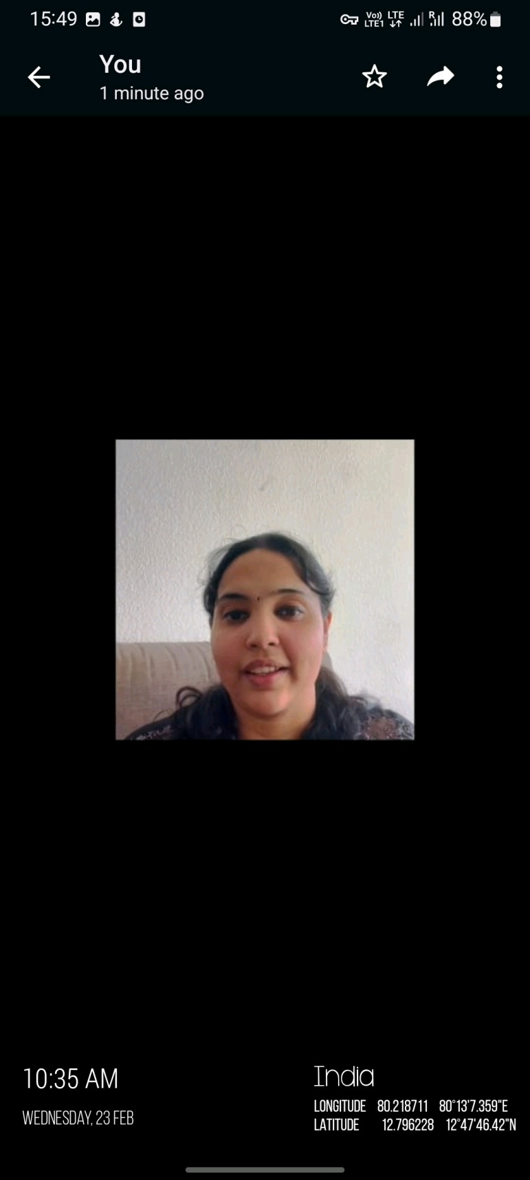

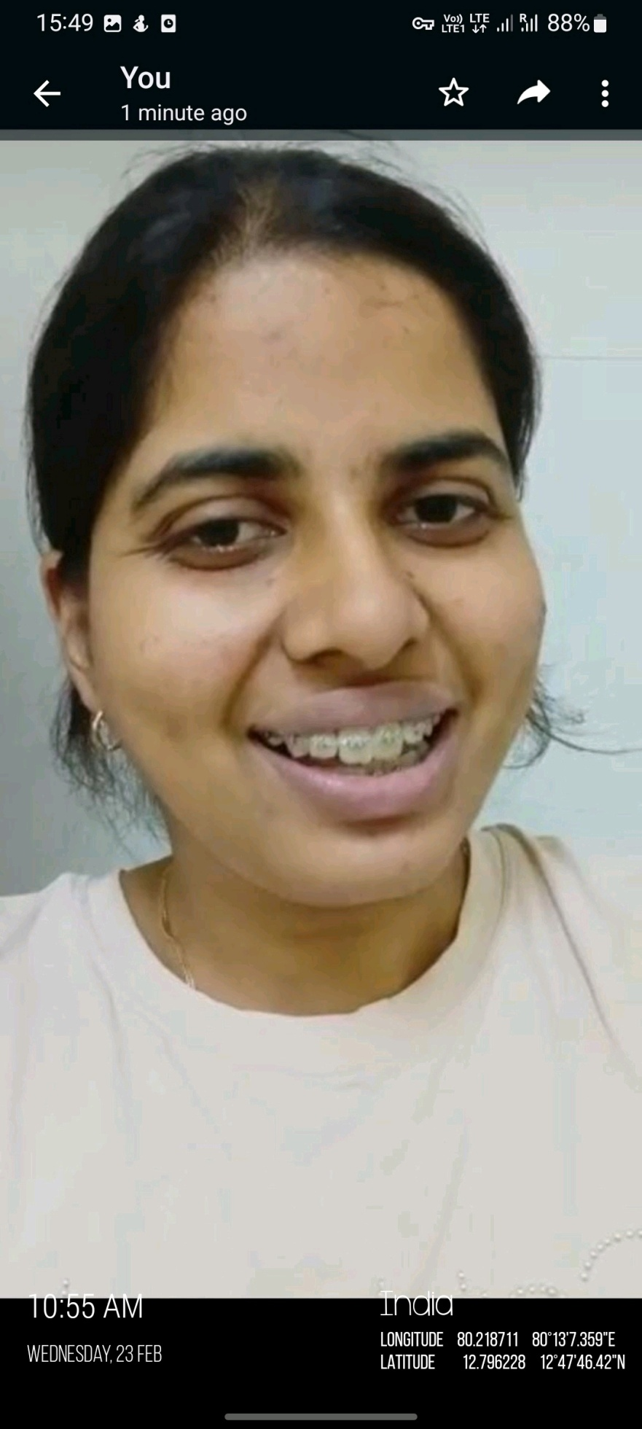

REPORT OF THE PROGRAM

TITLE OF THE PROGRAM: ‘Oro- facial Clefts & its management’

TYPE OF EVENT: Commemorative Event- Special Event

DATE & TIME: 30/07/2022 & 12.00pm- 1.00pm

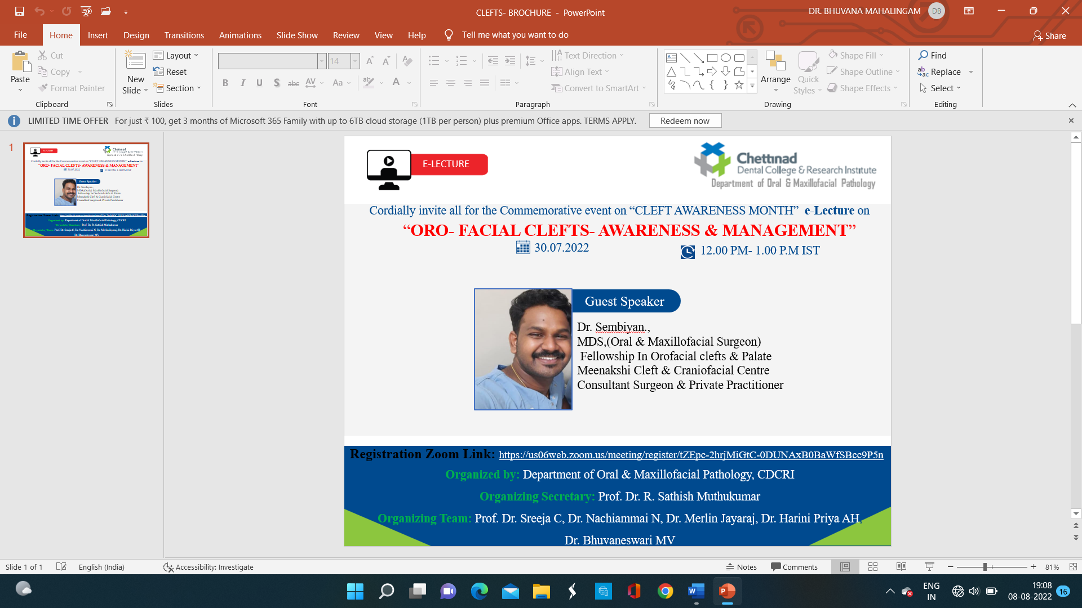

The program started by 12.00 pm on 30/07/2022. Dr.Bhuvaneswari gave introduction to the session with the participants of seventy-one Under graduates, four post graduates and three faculty members. Dr. Sathish Muthukumar moderated the session. Dr. Sembiyan, MDS who is currently pursuing his fellowship in Orofacial clefts & palate was the guest speaker of the session.

He started the session with defining clefts of lip and palate. He also described in detail about the various etiological factors involved in the formation of clefts of lip and palate. The clinical features which include signs and symptoms of the clefts of lip and palate were described in detail in an easy and understandable manner. The treatment strategies were also explained in clear and simple manner. The treatment plan along with the management of cleft lip and cleft palate were discussed separately for both the lesion. The session ended by 1.10 pm. Dr. Sathish Muthukumar added few points and also mentioned some of the syndromes associated with this lesion. He also presented Certificate to the guest speaker as a token of appreciation and the session ended with the conclusion note given by Dr. Bhuvaneswari.

FEEDBACK ANALYSIS:

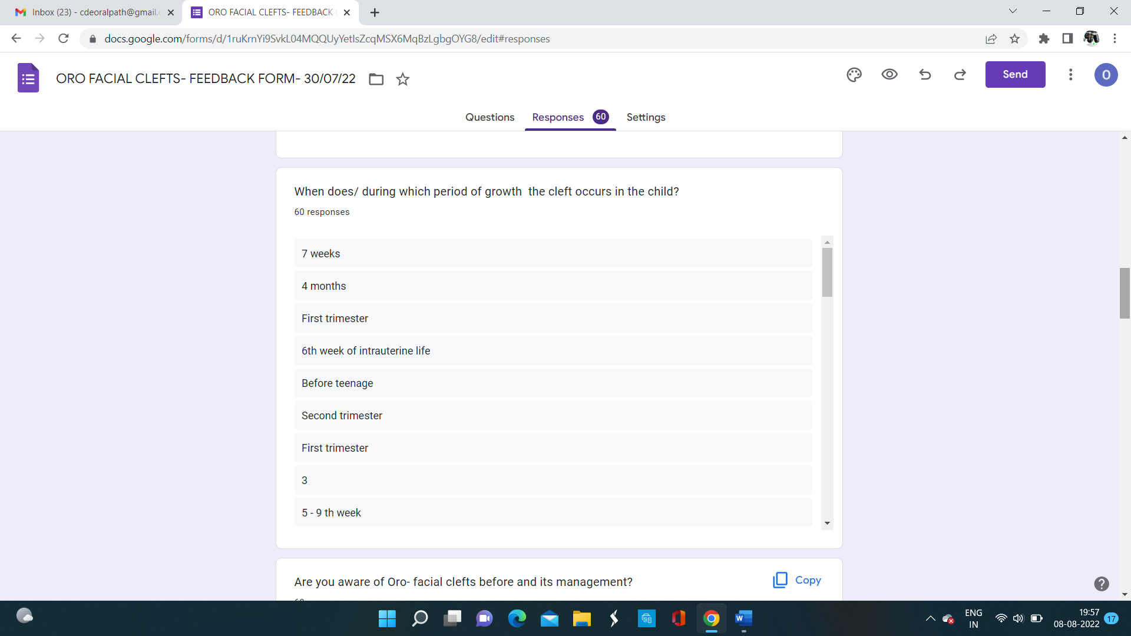

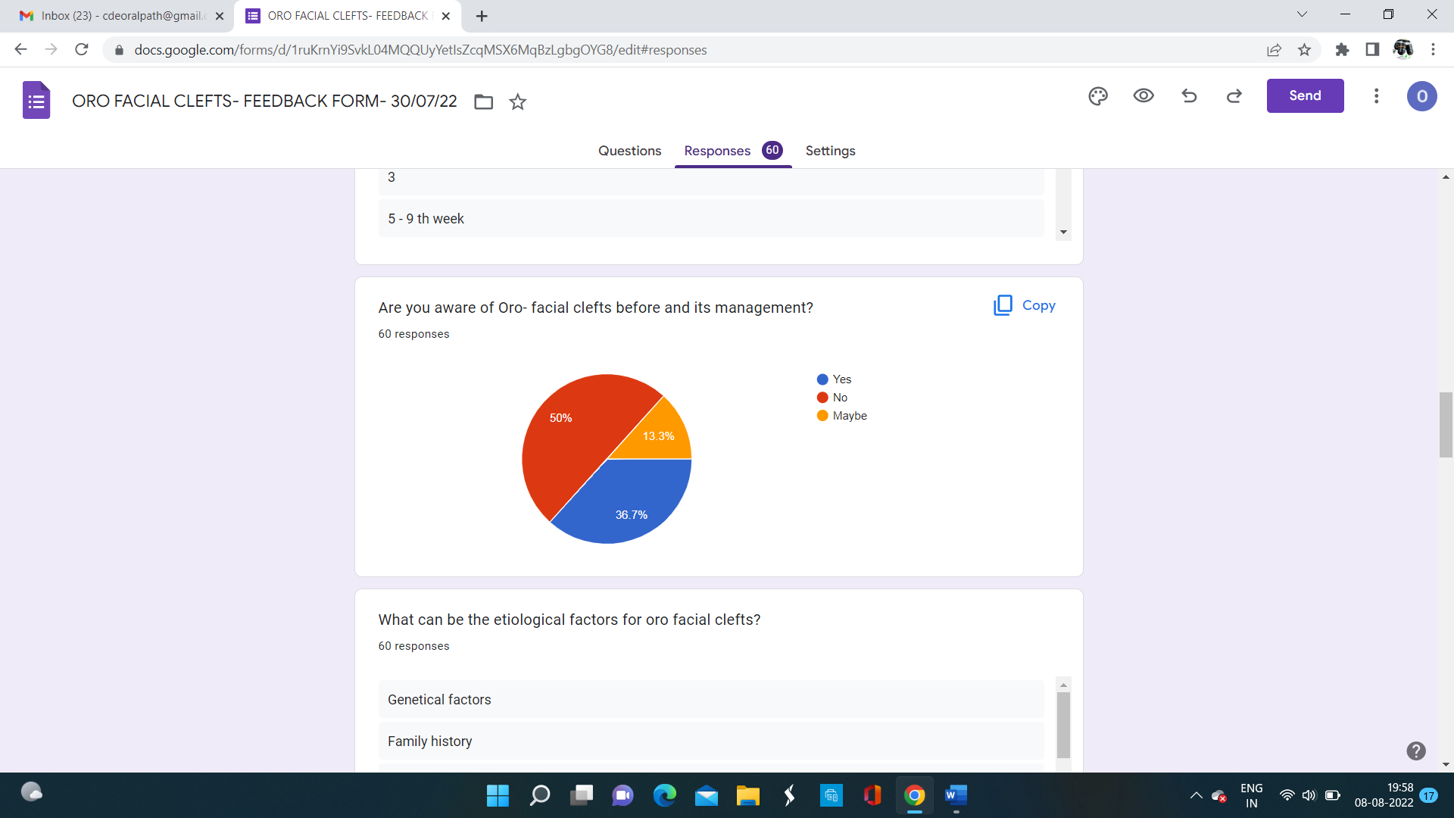

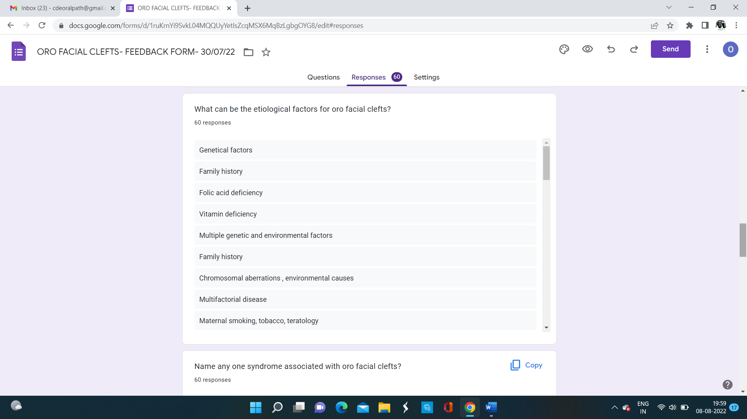

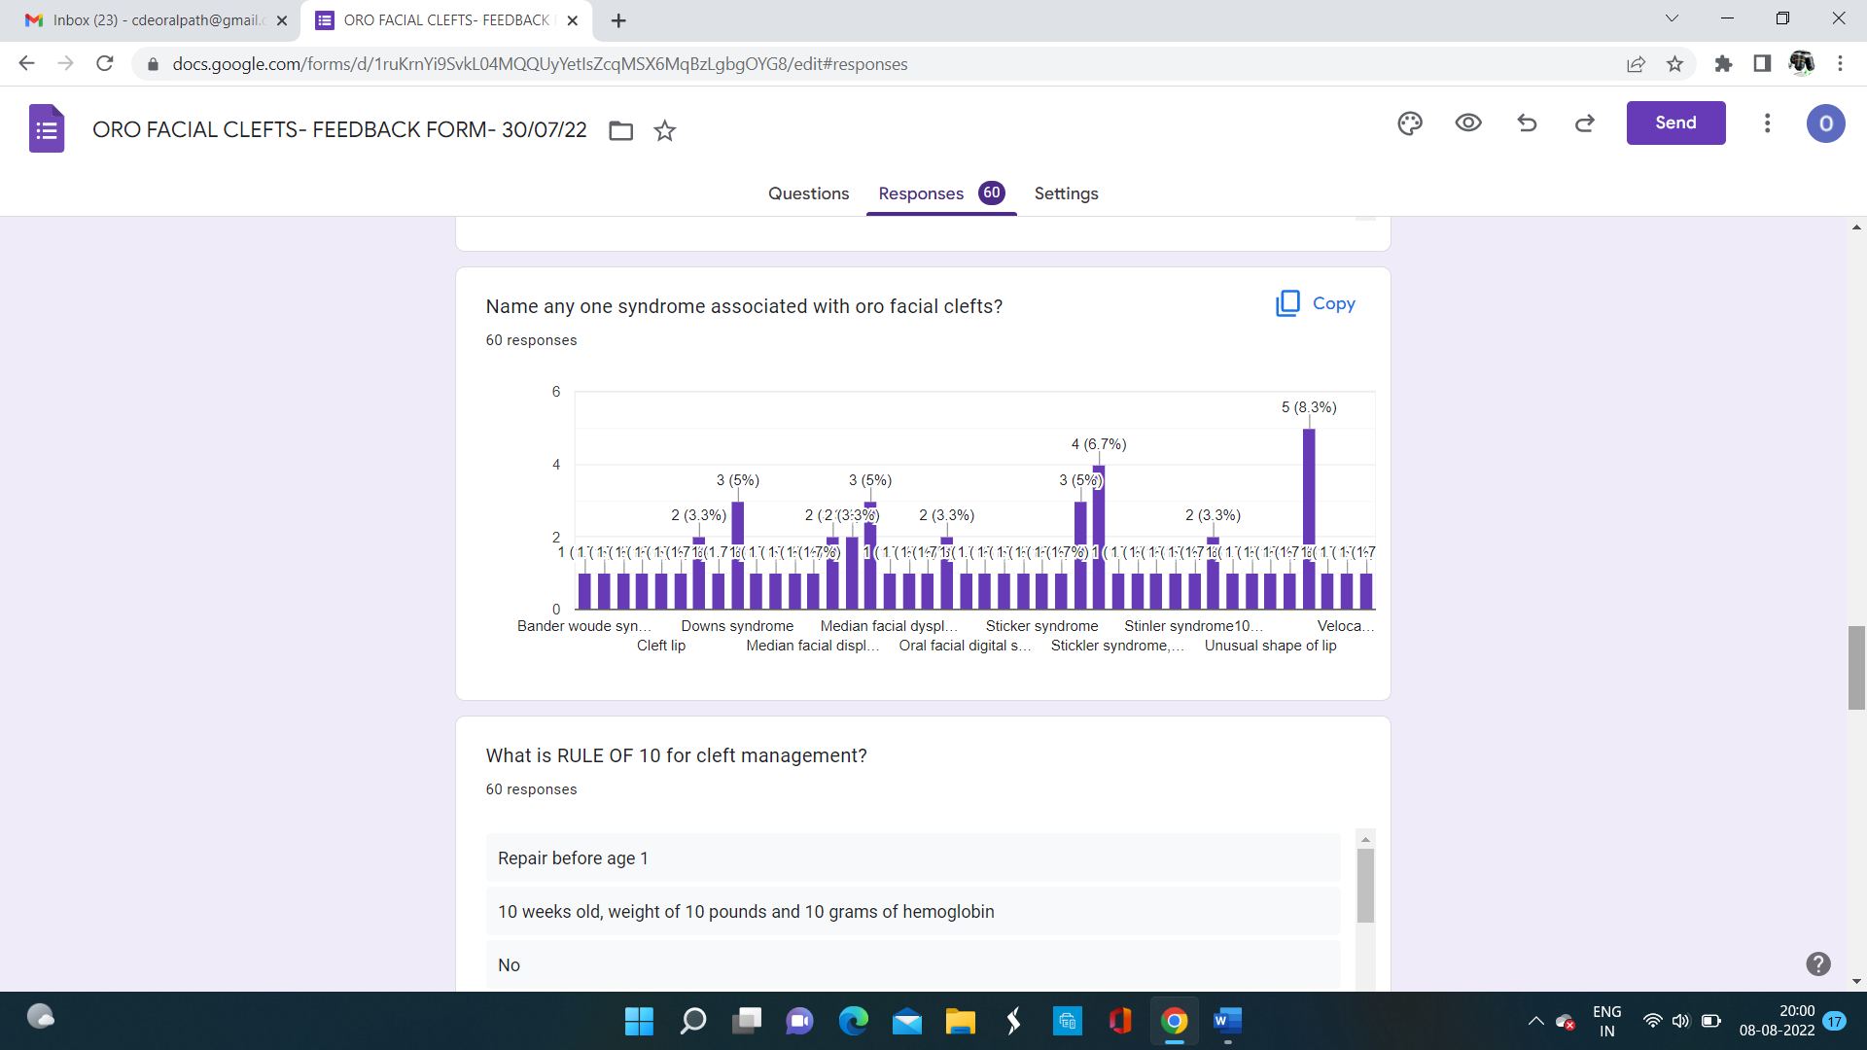

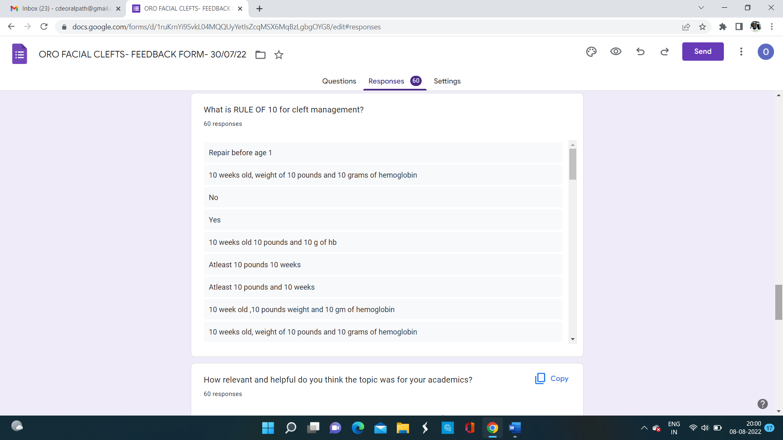

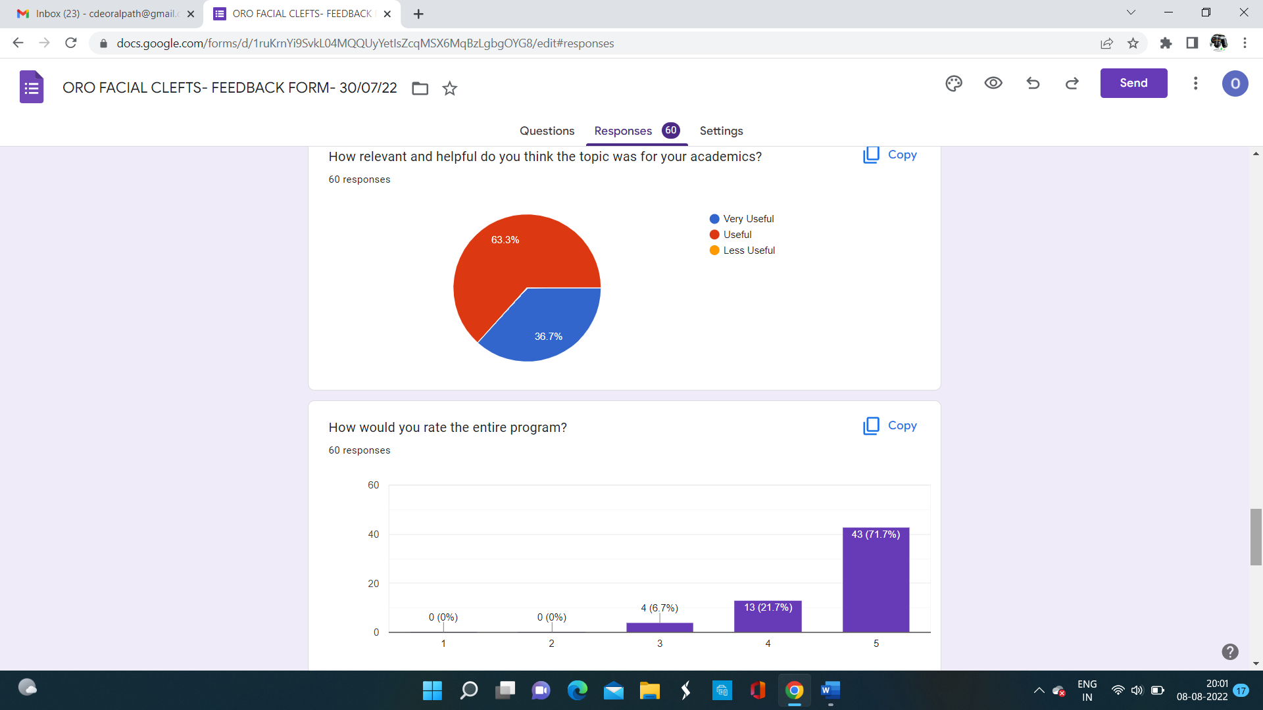

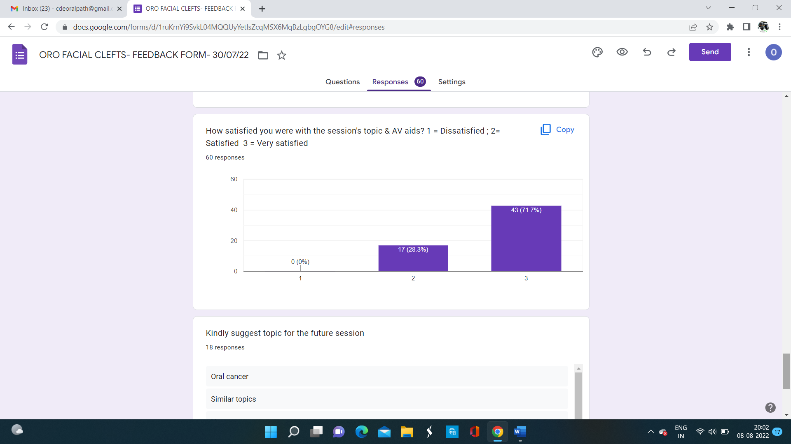

**PROGRAM CONSTRAINTS:**

None

**ACKNOWLEDGEMENT:**

* The Department of oral & maxillofacial pathology extends their thanks to management and administration for their support rendered
* Sincere thanks to Mr. Manikandan & team, IT department of the institution for their technical support.

